**CP Club 365Days Challenge**

**Date – 03/12/2022**

**Programming language – c++**

**Problem Statement**

**[https://practice.geeksforgeeks.org/problems/minimize-the-sum-of-product1525/1?page=1&category[]=Greedy&sortBy=submissions](https://practice.geeksforgeeks.org/problems/minimize-the-sum-of-product1525/1?page=1&category%5b%5d=Greedy&sortBy=submissions)**

**Your Code**:

// 0x47Day of 0x365Days challenge

// VEDANT BHARAD

// 03-12-2022

//{ Driver Code Starts

#include<bits/stdc++.h>

using namespace std;

// } Driver Code Ends

class Solution{

    public:

    long long int minValue(int a[], int b[], int n)

    {

        long int ans=0;

        sort(a,a+n);

        sort(b, b + n, greater<int>());

        for(int loop = 0; loop < n;loop++)

        {

            ans=ans+(a[loop]*b[loop]);

        }

        return ans;

    }

};

//{ Driver Code Starts.

int main()

{

    int t;

    cin>>t;

    while(t--)

    {

        int n, i;

        cin>>n;

        int a[n], b[n];

        for(i=0;i<n;i++)

        cin>>a[i];

        for(i=0;i<n;i++)

        cin>>b[i];

        Solution ob;

        cout<< ob.minValue(a, b, n) <<endl;

    }

    return 0;

}

// } Driver Code Ends

**Output (Screen Shot)**:

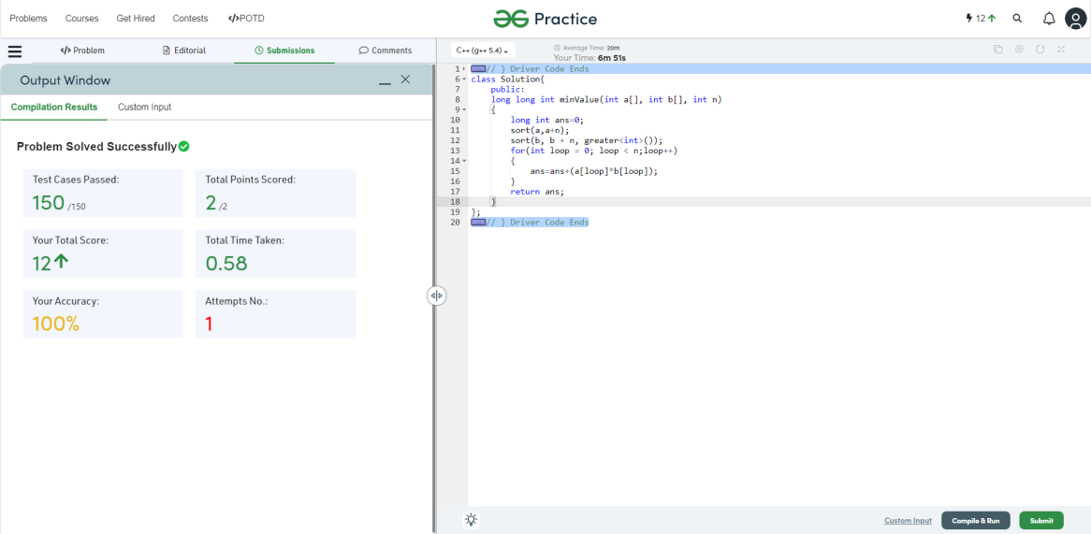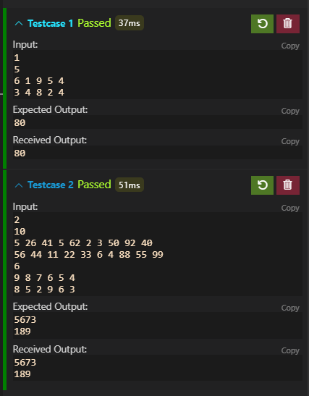

**Understanding about problem:**

1. In this task there are three inputs first is length second is array and at last second array
2. In this task first I need to sort array1 in ascending order and sort array2 in descending order then I need to multiply same index of both array and then add in other long int variable.

Note: If you can't understand the problem, feel free to contact us and we'll help you. Please don't copy and paste from anywhere.

ALL THE BEST

Team CP Club